Practical Lab 1
This introductory practical lab contains several tasks and has been designed with a view to introduce you to the course material and help you to get setup to program in Python. It’s also designed to encourage you to undertake a little research to explore some common programming terms. A set of example programs are presented that touch upon many of the concepts that you will further explore over the course of the module. For now, you are not expected to understand all (or any) of this code, nor those concepts which underpin it.

Task 1 – Organise your file structures and setup your OneDrive account
Keeping your files and folders organised over the course of the semester will help you to be more productive. As part of your registration with Ulster, you have been provided with Office 365 access, which included OneDrive providing 1TB of free online cloud storage. Files can be saved and accessed from any PC connected to the internet. We recommend that you use OneDrive as your primary file storage location - think of it as your "My Documents" in the cloud.

You can access the Office 365 account via Home-> Quick Links in the Ulster portal: https://portal.ulster.ac.uk/

We recommend that you organise your files and folders on OneDrive under a single folder called “data”. This makes it easy to locate other files and to more easily maintain weekly backups on a secondary storage device such as an USB pen-drive.

Within your data folder, we recommend that you create a new folder called COM161 and within this folder create three sub-folders: Lectures; Practical Labs and Other Resources. Within the Practical Labs subfolder, create a sub-folder for Week 1 Labs. You should now save as copy of this lab sheet and any code output from this lab session into the Week 1 Labs folder.

(Note that on some university workstations it may be necessary to save your programming file locally during developing, backing these up to your personal OneDrive at the end of end session).

Task 2 – Accessing Materials
Access Blackboard Ulster (https://learning.ulster.ac.uk), download (to the Lectures folder on your OneDrive) and review the Week 1 Lecture Slides found in the Week 1 folder . Take a bit of time to digest the introductory information provided and annotate with personal notes, where appropriate.

Access, download (to your OneDrive Other Resources folder) and review the COM161 Module Handout. Take note of the topics that lie ahead, contact details for the teaching team, class test dates and the assessment deadline.

Task 3 – Exploring the Software
We will use specialist software within the module to support you in writing your own Python programs.

To offer you some introductory practice with the IDLE Integrate Development Environment we will be using, you carry out the following steps:

  - Launch “IDLE”. To do this in Windows, click the Start button, then search for ‘IDLE’.
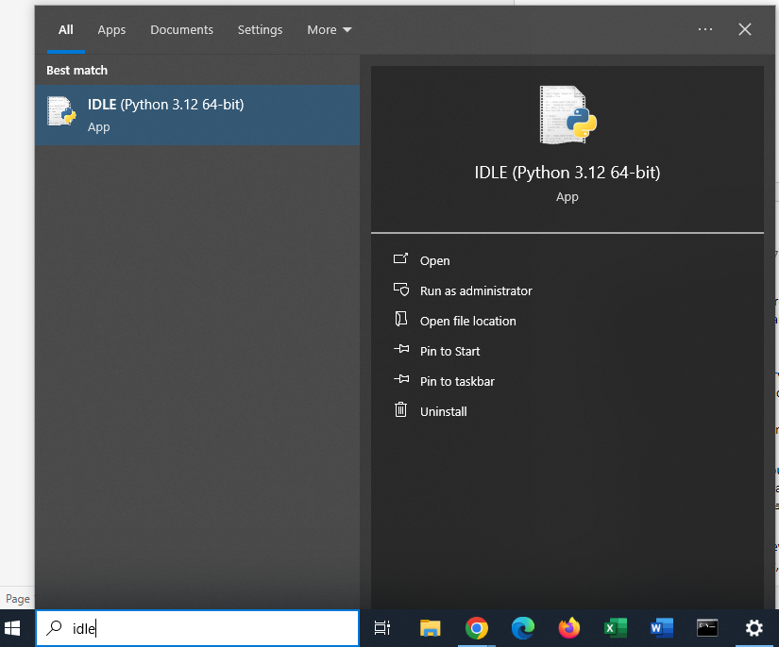

  - When IDLE starts, you should see a window appear onscreen. At the Python Interpreter prompt (>>>) type the following statement and then press Enter:
print('This is a test of IDLE.')

  - After pressing the Enter key the Python interpreter will execute the statement. If you
typed everything correctly, your session should look like this:
>>> print('This is a test of IDLE.')
This is a test of IDLE.
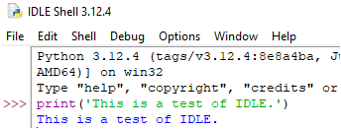
Notice what happens if you type the line again but put a full stop at the end and then try to execute the statement.
print('This is a test of IDLE.').

Task 4 – Writing your first proper program
The Python Interpreter, used in Task 3, works fine for small programs or when you wish to quickly test a new concept, however, writing code in a dedicated program file enables to save your program for future use. To launch a new editor, select File -> New from the main menu in IDLE. Name the file (Lab1_Task4.py) and save it to your Week 1 Labs folder on OneDrive (or temporarily save it locally as described under Task 1):

Transcribe the following code, line-by-line, into the IDLE editor window (please note that you do not type in the line numbers, they can be shown in the Options tab).
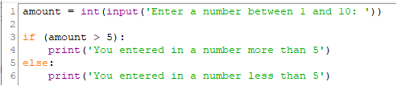

Then click on Run and then Run Module. You may be prompted to save the program, if not you will be able enter in a value on the interpreter line.

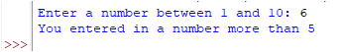

Don’t panic if you’re feeling lost already! You are not expected you to understand much, if any, of this code right now but do pay attention to the detail of what is being entered including capitalization, spacing, quote type, etc. Attention to detail is among the most important programming skills needed to become a competent developer.

Also, when naming your files – make sure there is no space between words

This is bad ----> Lab1 Task 4.py

This is good ---> Lab1_Task4.py

Having spaces in filenames can cause problems with certain operating systems and IDEs.

During these practicals, don’t be tempted to copy-paste the code!

You need to understand the basics. In future modules, you will encounter frameworks that generate a lot of code for you. But that will mean nothing to you, if you don’t know the basics.

Tip: the indents can be achieved by hitting the tab key on the keyboard or by pressing the spacebar 4 times.

SIDE TASK: take a few minutes to research the use of spacebar and spaces in Python: https://peps.python.org/pep-0008/ noting that most modern IDEs will do their best to help you as you code.
TEST YOUR CODE:
- did the code run?
- What error do you get if you enter a non-numerical character?
- Do decimal inputs work?
- Does changing the numbers in line 1 affect how the code works?
- Can you change the code so that the default criteria tests if the amount is less than or equal to 5?

Task 5 – writing your second program
Create a new file in the editor, save it as Lab1_Task5.py and enter the following code.

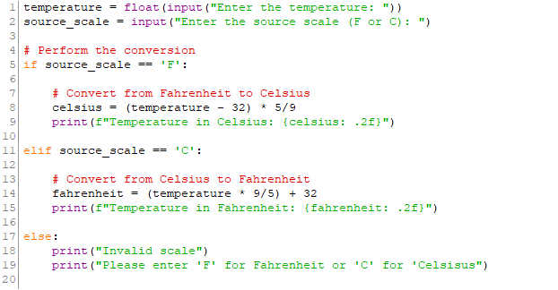

TEST YOUR CODE:
- did the code run? Did you test for both Celsisus and Fahrenheit?

You are not expected to understand all of syntax presented in this example, however:
- What do you make of the lines beginning with a #?
- What’s the purpose of ‘else’?
- Are the brackets important on line 8?

Optional
Can you spot the errors in the code that will prevent the program from running?

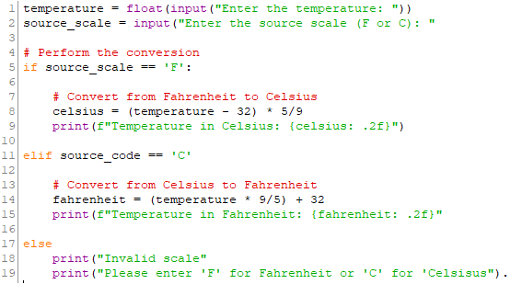

Task 6 - Turtle Demo
Turtle is a compact graphical program available within Python. It allows us to simulate a small robot that can follow navigational commands using an x, y coordinate space. Create a new editor window by selecting File then New within IDLE. Name the file (Lab1_Task6.py) and save it to your Week 1 Labs folder on your OneDrive.

Transcribe the following code, line-by-line, into the IDLE editor window.

Tip: as note above, never copy-paste code. Take time to write each line carefully and note the requirement for precise spelling and spacing which are fundamental to writing error-free programs. Note that copy-paste from PDF, in particular, often introduces unwanted results.

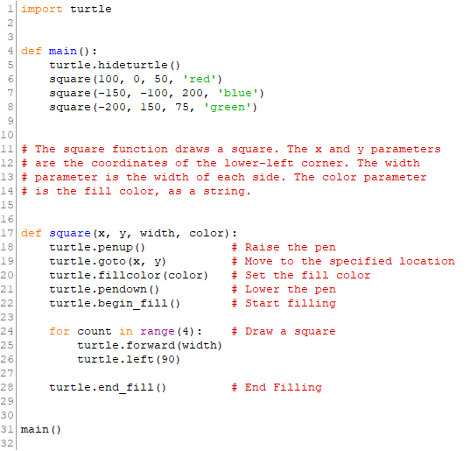

Execute the code by selecting Run->Run Module from the menu or by pressing F5 on your keyboard.

TEST YOUR CODE:
What do you observe?
How does adjusting the numbers in lines 6, 7 and 8 affect the code?
What are the lines in red offering?
How does adjusting the number in ‘turtle.left(90)’ affect the output?

Task 7 – More Turtle
Access the Week 1 Self-guided Turtle Tutorial provided within the Week folder. Explore the slides, and attempt the ‘try it out’ exercises.

Task 8 – Researching Python
Use a suitable web search engine to answer the following questions. We may review some of the answers in Week 2.

- Who was the creator of Python?
- When was the Python programming language created?
- How many major revisions has the language gone through?
- As of 2024, how popular is the Python Programming language reported to be?
- What does IDE stand for and what is its purpose?
- What is the difference between an integer and float in python?
- How are strings are stored in Python?
- What is a variable and how are they used in programming?
- How does the print statement in Python work?
- What is PEP8 in the context of Python?
- What is ASCII coding and what are the codes for ‘A’ and ‘a’?
- What are the ASCII codes for your first name?

Additional Task – Configuring your PC/Laptop for ‘home use’

We recommend that you configure your own personal laptop / desktop so that you are able to practice programming off campus. In this module, we’ll be programming in Python 3 (v3.10) and to support this, you may have to download and install several files. The official distribution of python is available at https://www.python.org but before you visit that site, you are encouraged to review the ‘Help with installing’ links set out below.

Help with installing

There are hundreds of ‘get started’ articles and videos online. Here, we recommend one of each and you are encouraged to take time to understand why this s
- Article covering installation on Windows and MacOS - https://realpython.com/installing-python/
- Video guide for Windows and MacOS - https://www.youtube.com/watch?v=YYXdXT2l-Gg

Later in the module, we’ll be introducing a more advanced IDE called PyCharm – you can download a free version at the link below. Don’t worry if you don’t have time right now as we’ll revisit this activity later in the course.

https://www.jetbrains.com/pycharm-edu/



You’ll find lots of information about all of the IT services available to students on the ISD Website: https://www.ulster.ac.uk/ds/students

